WAN Protocol
When we are using serial links on cisco routers, we use the following two protocols.
HDLC (Higher Level Data Control) Protocol:
PPP (Point to Point Protocol):
HDLC | PPP | Notes
Cisco Proprietary | Open standard
Default on serial links on Cisco Routers | Change to PPP | If you are connecting a cisco router with another vendor, or none of them are cisco, then we use PPP.
Read further here: Difference Between High-level Data Link Control (HDLC) and Point-to-Point Protocol (PPP) - GeeksforGeeks

INSERT THE TOPLOGY SCREENSHOT HERE
Now let’s configure the above topology.
We have 5 networks in total. Remember each router’s interface is considered as different network. To each router, there are some networks which are directly connected with the routers but there are some networks which are not connected directly. Those which are not connected directly, we need to define them in each router.
Take a look at the following table to see direct (connections) and indirect (missing) connections.
Router Name | Direct connections (C) | Indirect Connections
Router0 | 1.0.0.0/8 | 2.0.0.0/8
 | 192.168.1.0/24 | 192.168.2.0/24
 |  | 192.168.3.0/24
Router1 | 2.0.0.0/8  1.0.0.0/8  192.168.1.0/24 | 192.168.1.0/24  192.168.3.0/24
Router2 | 2.0.0.0/8  192.168.3.0/24 | 1.0.0.0/24  192.168.2.0  192.198.1.0/24

It’s straight forward to configure the direct connected networks. However, you will need some skills to configure the networks not directly connected.
Lets configure the directly connected interfaces first.
Router0:
Go to Router0, CLI mode, and enter the configuration terminal mode then following steps.
Interface serial0/0
Ip address 1.1.1.1 255.0.0.0
No shut
Exit
Interface FastEthernet 0/0
Ip address 192.168.1.100 255.255.255.0 (This is the gateway IP and must be configured on all PCs in this network)

Router1:
Now go to Router1, CLI mode, and enter the configuration terminal mode then following steps.
Interface serial0/0
Ip address 1.1.1.2 255.0.0.0
No shut
Interface serial 0/1
Ip address 2.1.1.1 255.0.0.0
No shut
Exit
Interface FastEthernet 0/0
Ip address 192.168.2.100 255.255.255.0 (again, this is the gateway IP and must be configured on all PCs in this network)
Router2:
Finally, go to Router1, CLI mode, and enter the configuration terminal mode then following steps.
Interface serial0/0
Ip address 2.1.1.2 255.0.0.0
No shut
Exit
Interface FastEthernet 0/0
Ip address 192.168.3.100 255.255.255.0 (again, this is the gateway IP and must be configured on all PCs in this network)
No shut
Exit from configuration mode and type the following command to see the IP route.
Show ip route
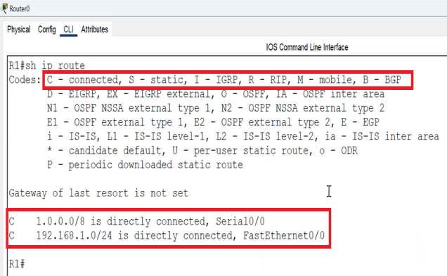
You can see the networks with “C” which resembles a direct connected network.
That is all done for direct connections (interfaces) on each router. However, you will still not be able to communicate with PCs from one network with another (i.e., a PC in network 192.168.1.0 will not be able to communicate with a PC in network 192.168.2.0) because they are not directly connected to each other. In order to work this out, you will need to configure the interfaces on each router which are not directly connected. In other words, you will need to tell the router where to send a packet if it is not in his direct connection by defining all other networks in each router. If we don’t configure them, the router will think the packet was not intended for it or for any other router in his network. By doing so, we are giving each router a list of connected network devices in his entire (WAN) network. You can do this by performing the following steps on each router.
Defining indirect networks in Router0:
Go to CLI Mode of Router0 and type the following commands:

